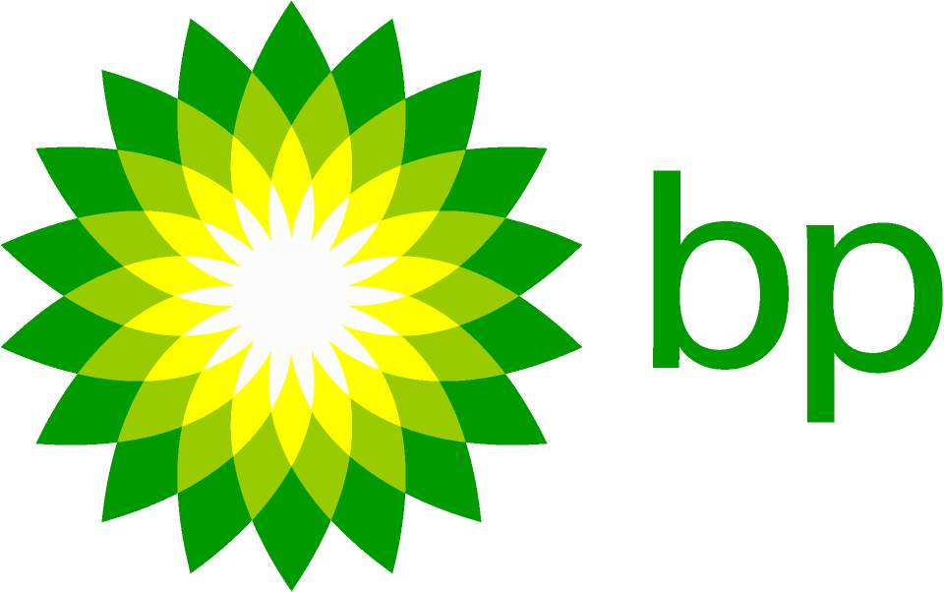
“Like all people, we are a company that has given and still is giving sincere apologies to Greenpeace and all those who witnessed and have participated in the cleaning up of our oil spills in the Antarctic waters. Our company never dreamed of spilling oil in Antarctica. Our wrong doings were all an accident, and weren’t planned to happen in first place. If we had the ability to stop these things from happening before they happened, we would definitely ensure this will be stopped. We do our best to help clean the mess no matter the size and time it will take to fix the problem. We are making improvements to a safety and procedures to ensure that there will be less oil spills in the future.“

