Perspectives: Bp Oil company- Oil spills

Perspective:
As one company, we want to prevent oil spills before they happen and we try to respond the best we can to oil spills. We never intentionally release oil into the ocean and it is always an accident. Right now we are making improvements to a safety and procedures to ensure that there will be less oil spills in the future. We do learn from our mistakes.

Reason for Perspective:
The more oil that gets spilt into the ocean costs us money and bad publicity as well as damage to marine life and ecosystems. There is a need for oil everywhere and so when we ship it across seas we always run the risk of an accident. We never intentionally spill oil into the sea as that would affect the oceans ecosystems. We understand about the environmental impacts and are trying to minimise risk. When an oil spill takes place we will respond effectively because we have new response tools such as a deployable capping stack device to quickly cap a well.

Actions taken as result:

BP has incorporated lessons learned through the Gulf of Mexico response and restoration efforts into the way we approach oil spills across our business – from the planning phase to identify and assess oil spill risk, responding to a spill using new and existing technologies and successfully addressing potential environmental and social impacts

http://www.bp.com/sectiongenericarticle800.do?categoryId=9040203&contentId=7067128

Why they did these methods:

BP wanted to learn from past disasters and make their response procedure better. They did this because they wanted to be able to deal with oil spills in a faster, better and in a more efficient way. If they dealt with oil spills faster, better and more efficiently, then the impact on marine wildlife would be reduced. There would then be less cleaning up and long term hindrances. They want to also be seen in a good light, making up for oil spill problems they caused by fixing them.

Impact on Society:
Because BP have learned from their mistakes and have created better solutions to oil spills this effects society by helping the environment recover and minimizing impacts on sea life. This in turn helps society because we are on the top of the food chain and fish beneath us. If the bottom of the food chain is majorly effected so will the top. Society might also think that BP is an oil company that really cares about the environment then they will use BP oil because BP cares about the environment and has concern for the environmental impacts it produces.
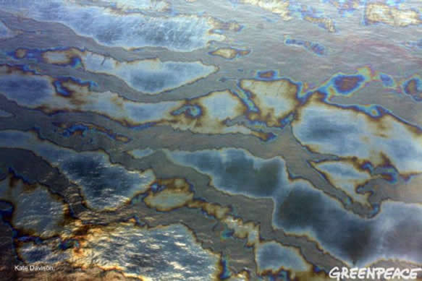
By: Hayley
